Nombre: ______________________________ PD: _____ proyecto pequeño – el tiempo libre poster
- 10 actividades diferentes en español (__/10 pts)
- 10 boxes (__/10 pts)
/35
-3 sentences in each box
-1 sentence in the I form
-2 sentences in the he/she or they form about your friends
- 10 fotos (NEATLY drawn or printed from internet and glued on paper) (__/5 pts)
- Correct spelling, accents, verb endings (__/5 pts)
- Attractive and creative (Use a ruler so you have straight lines!) (5 pts)
Example: (Final result will have all 10 boxes filled in)
Yo (no) practico deportes en mi tiempo libre.

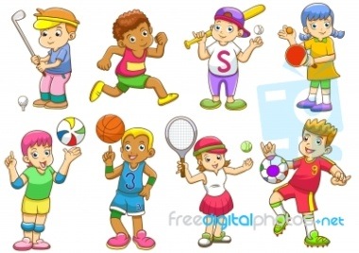

Mi amigo Juan (no) practica deportes.
Mi amiga Rachel (no) practica deportes.

1 = below basic 2 = basic/does not meet requirement 3 = developing

4 = level appropriate/meets requirement 5 = outstanding/few errors (x2 for 10 point categories)

