Escribe una frase para decir lo que le gusta cada persona.
MODELO: A mí me gusta estudiar.

infinitivo
A mí
A tí
A él
A ella
A usted
me gusta
te gusta
le gusta
+ +

- (Michael Jordan) ____________________________________________________
- (yo)_ ______________________________________________________________
- (mi mamá)_____________________________________________________________
- 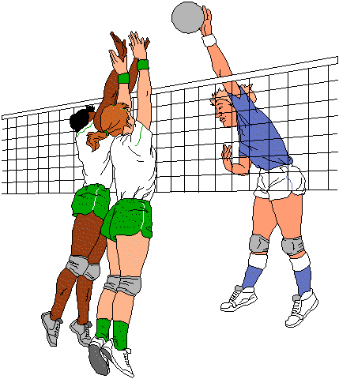(tú) __________________________________________________________________
- (Usted)________________________________________________________________
- (Bart Simspon)____________________________________________________
- (Elena)____________________________________________________________
- (yo) _______________________________________________________________

