Examen oral: Unidad 2.1 Date of examen oral: _________________________
Example pictures: Nombre: ___________________________ PD: ______
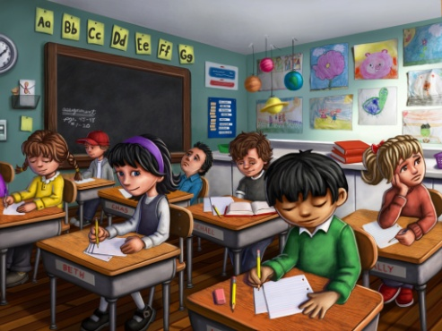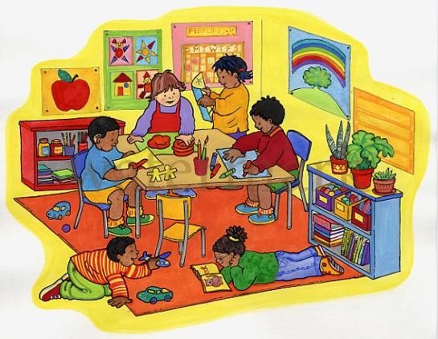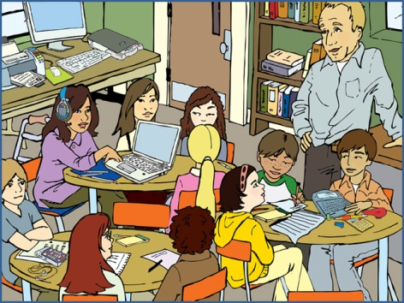
Fair game questions:
- ¿Qué hace ella/él? What is he/she doing? Respond in the “he/she” form (a/e ending) and explain what the person I point to is doing.
- ¿Qué hay en la clase? Respond and tell me the vocabulary words that appear in the class
- ¿Qué hay en la mochila? Respond and tell me the vocabulary words that appear in the backpack
- ¿Es un buen o mal estudiante? Respond and tell me if the person I point to is a good or bad student and tell me why (What is he/she doing that supports your response?).
- ¿Qué clases tienes? What classes do you have Respond using “tengo” (I have) and explain to me what classes you have, who the maestro/maestro is and what period (periodo dos, tres, etc.)
 | 1 | 2 | 3 | 4 | 5 | Total
Gramática/use of verbs (x2) | Verbs used incorrectly | Verbs used more incorrectly than correctly | Developing- Verbs used somewhat correctly | Verbs used mostly correctly, comprehension not impeded | Verbs used correctly, comprehensible | /10
Use of vocabulario | Below-basic | Basic | Developing | Level appropriate | Outstanding | /5
Quality of response/preparation | Below-basic | Basic | Developing | Level appropriate | Outstanding | /5
Fluency | Abundant hesitation | Much hesitation | Some hesitation | Level appropriate hesitation | Minimal to no hesitation | /5
Comments/notes:

/25
+2 if you have this paper the day of the oral exam

